Для разработки авторизации требуется строка подключения к базе данных:

Data Source=KRISTINA\SQLEXPRESS;Initial Catalog=PP_Sadikova;Integrated Security=True;Encrypt=False

Код C#:

using System;

using System.Collections.Generic;

using System.ComponentModel;

using System.Data;

using System.Data.SqlClient;

using System.Drawing;

using System.Linq;

using System.Text;

using System.Threading.Tasks;

using System.Windows.Forms;

namespace PP_SADIKOVA

{

public partial class Avtorizaciya : Form

{

public Avtorizaciya()

{

InitializeComponent();

}

private void b_2_Click(object sender, EventArgs e)

{

this.Close();

}

private void b_1_Click(object sender, EventArgs e)

{

SqlConnection sqlcon = new SqlConnection(@"Data Source=KRISTINA\SQLEXPRESS;Initial Catalog=PP_Sadikova;Integrated Security=True;Encrypt=False");

string query = "Select * from Polzovateli Where [Login] = '" + tb_1.Text.Trim() + "' and [Parol] = '" + tb_2.Text.Trim() + "'";

SqlDataAdapter sda = new SqlDataAdapter(query, sqlcon);

DataTable dttbl = new DataTable();

sda.Fill(dttbl);

if (dttbl.Rows.Count == 1)

{

string userRole = dttbl.Rows[0]["Roli"].ToString();

if (userRole == "Admin")

{

Menu_Administratora gn = new Menu_Administratora();

this.Hide();

gn.ShowDialog();

this.Show();

}

else if (userRole == "User")

{

Menu_Polzovatelya gn = new Menu_Polzovatelya();

this.Hide();

gn.ShowDialog();

this.Show();

}

}

else

{

MessageBox.Show("Не верно введен логин или пароль");

tb_1.Clear();

tb_2.Clear();

}

}

}

}

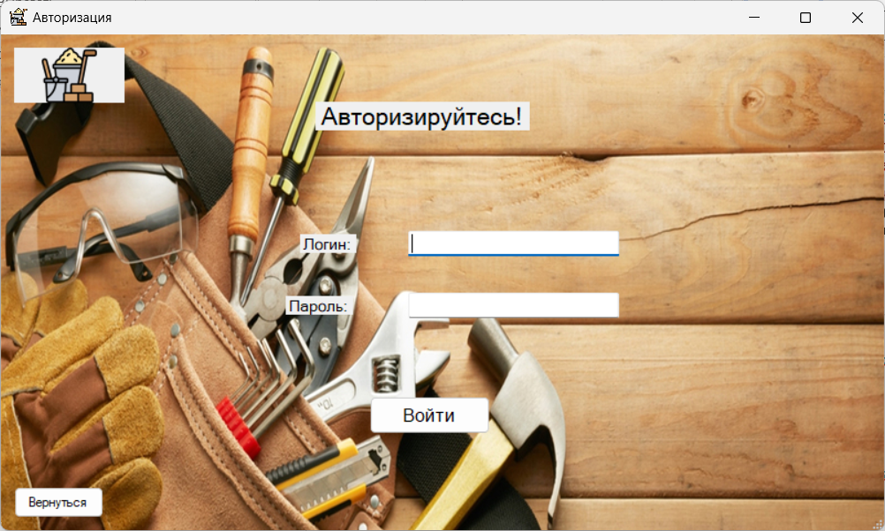

Рис 1. Окно Авторизации

Данные для входа:

|  |  |  |
| --- | --- | --- |
| Login | Parol | Roli |
| olga@mail.ru | Oli#987 | User |
| a.volkov@mail.ru | Vol*123 | User |
| irina.kozlova@yandex.ru | Koz$568 | User |
| d.novikov@gmail.com | Nov!469 | User |
| e.fedorova@mail.ru | Fed&570 | User |
| artem.vas@yandex.ru | Vas#571 | User |
| marina.sokol@inbox.ru | Sok*572 | User |
| s.morozov@mail.ru | Mor%573 | User |
| a.pavlova@gmail.com | Pav$574 | User |
| v.lebedev@yandex.ru | Leb&575 | User |
| t.vinograd@mail.ru | Vin#576 | User |
| p.grig@inbox.ru | Gri*577 | User |
| y.kovaleva@yandex.ru | Kov$578 | User |
| kirill.bor@mail.ru | Bor%579 | User |
| a.frolova@gmail.com | Fro&580 | User |
| g.nikolaev@yandex.ru | Nik#581 | User |
| v.semenova@mail.ru | Sem*582 | User |
| r.timofeev@inbox.ru | Tim%583 | User |
| alla.romanova@mail.ru | Rom$584 | User |
| den.alekseev@yandex.ru | Ale&585 | User |
| val.kuzmina@gmail.com | Kuz#586 | User |
| grig.orlov@mail.ru | Orl*587 | User |
| e.dmitrieva@yandex.ru | Dmi%588 | User |
| m.stepanov@inbox.ru | Ste$589 | User |
| l.petrova@mail.ru | Pet&590 | User |
| a.ivanov@mail.ru | Iva@2020 | Admin |
| m.kuz@mail.ru | Kuz@2021 | Admin |
| s.petrov@yandex.ru | Pet@2019 | Admin |
| e.smirnova@company.com | Smi@2022 | Admin |
| d.volkov@buildmail.ru | Vol@2020 | Admin |
| o.novikova@mail.ru | Nov@2023 | Admin |
| i.fedorov@yandex.ru | Fed@2018 | Admin |
| a.kozlova@company.com | Koz@2021 | Admin |
| p.morozov@buildmail.ru | Mor@2022 | Admin |
| v.sokolova@mail.ru | Sok@2020 | Admin |
| a.lebedev@yandex.ru | Leb@2023 | Admin |
| t.vasnecova@company.com | Vas@2019 | Admin |
| n.grigoriev@buildmail.ru | Gri@2021 | Admin |
| y.pavlova@mail.ru | Pav@2022 | Admin |
| a.nikolaev@yandex.ru | Nik@2020 | Admin |
| s.borisova@company.com | Bor@2023 | Admin |
| k.alekseev@buildmail.ru | Ale@2019 | Admin |
| e.dmitrieva@mail.ru | Dmi@2021 | Admin |
| m.timofeev@yandex.ru | Tim@2022 | Admin |
| a.frolova@company.com | Fro@2020 | Admin |
| d.vasiliev@buildmail.ru | Vas@2023 | Admin |
| a.romanova@mail.ru | Rom@2018 | Admin |
| g.semenov@yandex.ru | Sem@2021 | Admin |
| v.kuzmina@company.com | Kuz@2022 | Admin |
| r.orlov@buildmail.ru | Orl@2019 | Admin |